
Министерство образования и молодежной политики Свердловской области
ГАПОУ СО «Екатеринбургский колледж транспортного строительства»

Отчёт по программе «Практическое занятие 4»

Выполнил: Мелехова Марина
Группа: ПР-31
Преподаватель: Мирошниченко Г. В.
2026

Задание из документа
Разработать мобильное приложение, используя фрагменты. Информация в приложении должна сохраняться в SharedPreferences в формате JSON (библиотека Gson). Приложение должно содержать приветственный экран с авторизацией пользователя, проверкой ввода на пустоту и сохранением информации о пользователе через механизм SharedPreferences; форму ввода данных; экран для вывода сохранённой информации.
Вариант 9 – приложение «Плей-лист музыкальных дисков». Оформление приложения (цвета, иконки, надписи) выполнено в музыкальной тематике: виниловая пластинка, тёмно-фиолетовый фон и оранжевые акценты.
Для работы с JSON в файл build.gradle (Module) добавлена зависимость:
implementation("com.google.code.gson:gson:2.10.1")

Входные и выходные данные
name – строковый тип, String
login – строковый тип, String
password – строковый тип, String
passwordHash – строковый тип, String
isRegister – логический тип, Boolean
isLoggedIn – логический тип, Boolean
title – строковый тип, String
artist – строковый тип, String
year – целочисленный тип, Int
tracks – целочисленный тип, Int
genre – строковый тип, String
favorite – логический тип, Boolean
id – целочисленный тип, Long
user – объектный тип, User?
disc – объектный тип, Disc
discs – список объектов, MutableList<Disc>
json – строковый тип, String
prefs – объектный тип, SharedPreferences
savedInstanceState – объектный тип, Bundle?
currentYear – целочисленный тип, Int
Листинг программы:
Класс Storage (работа с SharedPreferences и Gson)
package com.example.pr18_melekhovamarina

import android.content.Context
import android.content.SharedPreferences
import com.google.gson.Gson
import com.google.gson.reflect.TypeToken
import java.security.MessageDigest

class Storage(context: Context) {

private val prefs: SharedPreferences =
context.getSharedPreferences(PREFS_FILE, Context.MODE_PRIVATE)
private val gson = Gson()

fun saveUser(user: User) {
prefs.edit().putString(KEY_USER, gson.toJson(user)).apply()
}

fun getUser(): User? {
val json = prefs.getString(KEY_USER, null) ?: return null
return try {
gson.fromJson(json, User::class.java)
} catch (e: Exception) {
null
}
}

fun setLoggedIn(value: Boolean) {
prefs.edit().putBoolean(KEY_LOGGED_IN, value).apply()
}

fun isLoggedIn(): Boolean = prefs.getBoolean(KEY_LOGGED_IN, false)

fun getDiscs(): MutableList<Disc> {
val json = prefs.getString(KEY_DISCS, null) ?: return mutableListOf()
val type = object : TypeToken<MutableList<Disc>>() {}.type
return try {
gson.fromJson<MutableList<Disc>>(json, type) ?: mutableListOf()
} catch (e: Exception) {
mutableListOf()
}
}

private fun saveDiscs(list: List<Disc>) {
prefs.edit().putString(KEY_DISCS, gson.toJson(list)).apply()
}

fun addDisc(disc: Disc) {
val list = getDiscs()
list.add(disc)
saveDiscs(list)
}

fun removeDisc(id: Long) {
val list = getDiscs()
list.removeAll { it.id == id }
saveDiscs(list)
}

fun clearDiscs() {
prefs.edit().remove(KEY_DISCS).apply()
}

companion object {
private const val PREFS_FILE = "pr18_prefs"
private const val KEY_USER = "user"
private const val KEY_DISCS = "discs"
private const val KEY_LOGGED_IN = "logged_in"

fun hash(password: String): String =
MessageDigest.getInstance("SHA-256")
.digest(password.toByteArray())
.joinToString("") { "%02x".format(it) }
}
}

Класс MainActivity
package com.example.pr18_melekhovamarina

import android.os.Bundle
import androidx.appcompat.app.AppCompatActivity
import androidx.core.view.ViewCompat
import androidx.core.view.WindowInsetsCompat
import androidx.fragment.app.Fragment
import com.google.android.material.bottomnavigation.BottomNavigationView

class MainActivity : AppCompatActivity(),
AuthFragment.Callbacks,
AddDiscFragment.Callbacks,
DiscListFragment.Callbacks {

private lateinit var storage: Storage
private lateinit var bottomNav: BottomNavigationView

override fun onCreate(savedInstanceState: Bundle?) {
super.onCreate(savedInstanceState)
setContentView(R.layout.activity_main)

ViewCompat.setOnApplyWindowInsetsListener(findViewById(R.id.root)) { v, insets ->
val bars = insets.getInsets(WindowInsetsCompat.Type.systemBars())
v.setPadding(bars.left, bars.top, bars.right, bars.bottom)
insets
}

storage = Storage(this)
bottomNav = findViewById(R.id.bottom_nav)

bottomNav.setOnItemSelectedListener { item ->
when (item.itemId) {
R.id.nav_list -> showFragment(DiscListFragment())
R.id.nav_add -> showFragment(AddDiscFragment())
else -> return@setOnItemSelectedListener false
}
true
}

val loggedIn = storage.isLoggedIn() && storage.getUser() != null
bottomNav.visibility = if (loggedIn) android.view.View.VISIBLE else android.view.View.GONE

if (savedInstanceState == null) {
if (loggedIn) showMain() else showAuth()
}
}

private fun showFragment(fragment: Fragment) {
supportFragmentManager.beginTransaction()
.replace(R.id.fragment_container, fragment)
.commit()
}

private fun showAuth() {
bottomNav.visibility = android.view.View.GONE
showFragment(AuthFragment())
}

private fun showMain() {
bottomNav.visibility = android.view.View.VISIBLE
bottomNav.menu.findItem(R.id.nav_list).isChecked = true
showFragment(DiscListFragment())
}

override fun onAuthSuccess() = showMain()

override fun onDiscSaved() {
bottomNav.selectedItemId = R.id.nav_list
}

override fun onLogout() {
storage.setLoggedIn(false)
showAuth()
}
}

Класс AuthFragment (регистрация и вход)
package com.example.pr18_melekhovamarina

import android.content.Context
import android.os.Bundle
import android.view.LayoutInflater
import android.view.View
import android.view.ViewGroup
import android.widget.TextView
import androidx.fragment.app.Fragment
import com.google.android.material.button.MaterialButton
import com.google.android.material.textfield.TextInputLayout

class AuthFragment : Fragment() {

interface Callbacks {
fun onAuthSuccess()
}

private var callbacks: Callbacks? = null
private lateinit var storage: Storage

private var isRegister = true

private lateinit var tvTitle: TextView
private lateinit var tvSubtitle: TextView
private lateinit var tilName: TextInputLayout
private lateinit var tilLogin: TextInputLayout
private lateinit var tilPassword: TextInputLayout
private lateinit var btnAction: MaterialButton
private lateinit var tvToggle: TextView

override fun onAttach(context: Context) {
super.onAttach(context)
callbacks = context as? Callbacks
}

override fun onDetach() {
super.onDetach()
callbacks = null
}

override fun onCreateView(
inflater: LayoutInflater, container: ViewGroup?, savedInstanceState: Bundle?
): View = inflater.inflate(R.layout.fragment_auth, container, false)

override fun onViewCreated(view: View, savedInstanceState: Bundle?) {
super.onViewCreated(view, savedInstanceState)
storage = Storage(requireContext())

tvTitle = view.findViewById(R.id.tv_title)
tvSubtitle = view.findViewById(R.id.tv_subtitle)
tilName = view.findViewById(R.id.til_name)
tilLogin = view.findViewById(R.id.til_login)
tilPassword = view.findViewById(R.id.til_password)
btnAction = view.findViewById(R.id.btn_action)
tvToggle = view.findViewById(R.id.tv_toggle)

val hasUser = storage.getUser() != null
isRegister = savedInstanceState?.getBoolean(KEY_MODE) ?: !hasUser
updateMode(hasUser)

btnAction.setOnClickListener {
if (isRegister) register() else login()
}
tvToggle.setOnClickListener {
isRegister = !isRegister
clearErrors()
updateMode(hasUser)
}
}

override fun onSaveInstanceState(outState: Bundle) {
super.onSaveInstanceState(outState)
outState.putBoolean(KEY_MODE, isRegister)
}

private fun updateMode(hasUser: Boolean) {
if (isRegister) {
tvTitle.text = "Добро пожаловать!"
tvSubtitle.text = "Создайте аккаунт, чтобы собрать свой плей-лист дисков"
tilName.visibility = View.VISIBLE
btnAction.text = "Зарегистрироваться"
tvToggle.text = "Уже есть аккаунт? Войти"
} else {
tvTitle.text = "С возвращением!"
tvSubtitle.text = "Войдите, чтобы открыть свой плей-лист"
tilName.visibility = View.GONE
btnAction.text = "Войти"
tvToggle.text = "Зарегистрировать нового пользователя"
}
tvToggle.visibility = if (hasUser) View.VISIBLE else View.GONE
}

private fun clearErrors() {
tilName.error = null
tilLogin.error = null
tilPassword.error = null
}

private fun TextInputLayout.value(): String =
editText?.text?.toString()?.trim().orEmpty()

private fun validate(checkName: Boolean): Boolean {
clearErrors()
var ok = true
if (checkName && tilName.value().isEmpty()) {
tilName.error = "Введите имя"
ok = false
}
if (tilLogin.value().isEmpty()) {
tilLogin.error = "Введите логин"
ok = false
}
if (tilPassword.value().isEmpty()) {
tilPassword.error = "Введите пароль"
ok = false
} else if (checkName && tilPassword.value().length < 4) {
tilPassword.error = "Пароль – не менее 4 символов"
ok = false
}
return ok
}

private fun register() {
if (!validate(checkName = true)) return

val user = User(
name = tilName.value(),
login = tilLogin.value(),
passwordHash = Storage.hash(tilPassword.value())
)
storage.clearDiscs()
storage.saveUser(user)
storage.setLoggedIn(true)
callbacks?.onAuthSuccess()
}

private fun login() {
if (!validate(checkName = false)) return

val saved = storage.getUser()
if (saved == null ||
saved.login != tilLogin.value() ||
saved.passwordHash != Storage.hash(tilPassword.value())
) {
tilPassword.error = "Неверный логин или пароль"
return
}
storage.setLoggedIn(true)
callbacks?.onAuthSuccess()
}

companion object {
private const val KEY_MODE = "mode_register"
}
}

Класс AddDiscFragment (форма ввода данных)
package com.example.pr18_melekhovamarina

import android.content.Context
import android.os.Bundle
import android.view.LayoutInflater
import android.view.View
import android.view.ViewGroup
import android.widget.ArrayAdapter
import android.widget.CheckBox
import android.widget.Spinner
import android.widget.Toast
import androidx.fragment.app.Fragment
import com.google.android.material.button.MaterialButton
import com.google.android.material.textfield.TextInputLayout
import java.util.Calendar

class AddDiscFragment : Fragment() {

interface Callbacks {
fun onDiscSaved()
}

private var callbacks: Callbacks? = null
private lateinit var storage: Storage

private lateinit var tilTitle: TextInputLayout
private lateinit var tilArtist: TextInputLayout
private lateinit var tilYear: TextInputLayout
private lateinit var tilTracks: TextInputLayout
private lateinit var spinGenre: Spinner
private lateinit var cbFavorite: CheckBox
private lateinit var btnSave: MaterialButton

override fun onAttach(context: Context) {
super.onAttach(context)
callbacks = context as? Callbacks
}

override fun onDetach() {
super.onDetach()
callbacks = null
}

override fun onCreateView(
inflater: LayoutInflater, container: ViewGroup?, savedInstanceState: Bundle?
): View = inflater.inflate(R.layout.fragment_add_disc, container, false)

override fun onViewCreated(view: View, savedInstanceState: Bundle?) {
super.onViewCreated(view, savedInstanceState)
storage = Storage(requireContext())

tilTitle = view.findViewById(R.id.til_disc_title)
tilArtist = view.findViewById(R.id.til_artist)
tilYear = view.findViewById(R.id.til_year)
tilTracks = view.findViewById(R.id.til_tracks)
spinGenre = view.findViewById(R.id.spin_genre)
cbFavorite = view.findViewById(R.id.cb_favorite)
btnSave = view.findViewById(R.id.btn_save)

val genres = resources.getStringArray(R.array.genres)
val adapter = ArrayAdapter(requireContext(), R.layout.spinner_item, genres)
adapter.setDropDownViewResource(R.layout.spinner_dropdown_item)
spinGenre.adapter = adapter

btnSave.setOnClickListener { saveDisc() }
}

private fun TextInputLayout.value(): String =
editText?.text?.toString()?.trim().orEmpty()

private fun saveDisc() {
tilTitle.error = null
tilArtist.error = null
tilYear.error = null
tilTracks.error = null

val title = tilTitle.value()
val artist = tilArtist.value()
val year = tilYear.value().toIntOrNull()
val tracks = tilTracks.value().toIntOrNull()
val currentYear = Calendar.getInstance().get(Calendar.YEAR)
var ok = true

if (title.isEmpty()) {
tilTitle.error = "Введите название диска"
ok = false
}
if (artist.isEmpty()) {
tilArtist.error = "Введите исполнителя"
ok = false
}
if (tilYear.value().isEmpty()) {
tilYear.error = "Введите год выпуска"
ok = false
} else if (year == null || year < 1900 || year > currentYear) {
tilYear.error = "Год от 1900 до $currentYear"
ok = false
}
if (tilTracks.value().isEmpty()) {
tilTracks.error = "Введите количество треков"
ok = false
} else if (tracks == null || tracks < 1 || tracks > 99) {
tilTracks.error = "От 1 до 99 треков"
ok = false
}
if (!ok) return

val disc = Disc(
id = System.currentTimeMillis(),
title = title,
artist = artist,
year = year!!,
genre = spinGenre.selectedItem.toString(),
tracks = tracks!!,
favorite = cbFavorite.isChecked
)
storage.addDisc(disc)
Toast.makeText(requireContext(), "Диск добавлен в плей-лист", Toast.LENGTH_SHORT).show()
clearForm()
callbacks?.onDiscSaved()
}

private fun clearForm() {
tilTitle.editText?.text?.clear()
tilArtist.editText?.text?.clear()
tilYear.editText?.text?.clear()
tilTracks.editText?.text?.clear()
spinGenre.setSelection(0)
cbFavorite.isChecked = false
}
}

Класс DiscListFragment (вывод сохранённой информации)
package com.example.pr18_melekhovamarina

import android.content.Context
import android.os.Bundle
import android.view.LayoutInflater
import android.view.View
import android.view.ViewGroup
import android.widget.TextView
import androidx.fragment.app.Fragment
import androidx.recyclerview.widget.LinearLayoutManager
import androidx.recyclerview.widget.RecyclerView
import com.google.android.material.button.MaterialButton
import com.google.android.material.dialog.MaterialAlertDialogBuilder

class DiscListFragment : Fragment() {

interface Callbacks {
fun onLogout()
}

private var callbacks: Callbacks? = null
private lateinit var storage: Storage
private lateinit var adapter: DiscAdapter

private lateinit var tvGreeting: TextView
private lateinit var tvSummary: TextView
private lateinit var tvEmpty: TextView
private lateinit var recycler: RecyclerView
private lateinit var btnLogout: MaterialButton

override fun onAttach(context: Context) {
super.onAttach(context)
callbacks = context as? Callbacks
}

override fun onDetach() {
super.onDetach()
callbacks = null
}

override fun onCreateView(
inflater: LayoutInflater, container: ViewGroup?, savedInstanceState: Bundle?
): View = inflater.inflate(R.layout.fragment_disc_list, container, false)

override fun onViewCreated(view: View, savedInstanceState: Bundle?) {
super.onViewCreated(view, savedInstanceState)
storage = Storage(requireContext())

tvGreeting = view.findViewById(R.id.tv_greeting)
tvSummary = view.findViewById(R.id.tv_summary)
tvEmpty = view.findViewById(R.id.tv_empty)
recycler = view.findViewById(R.id.recycler)
btnLogout = view.findViewById(R.id.btn_logout)

val userName = storage.getUser()?.name ?: "меломан"
tvGreeting.text = "Привет, $userName!"

adapter = DiscAdapter(storage.getDiscs()) { disc -> confirmDelete(disc) }
recycler.layoutManager = LinearLayoutManager(requireContext())
recycler.adapter = adapter

btnLogout.setOnClickListener { callbacks?.onLogout() }

refresh()
}

private fun refresh() {
val discs = storage.getDiscs()
adapter.submit(discs)

val favorites = discs.count { it.favorite }
tvSummary.text = "Дисков: ${discs.size} • Любимых: $favorites"

if (discs.isEmpty()) {
tvEmpty.visibility = View.VISIBLE
recycler.visibility = View.GONE
} else {
tvEmpty.visibility = View.GONE
recycler.visibility = View.VISIBLE
}
}

private fun confirmDelete(disc: Disc) {
MaterialAlertDialogBuilder(requireContext())
.setTitle("Удалить диск?")
.setMessage("«${disc.title}» – ${disc.artist}")
.setPositiveButton("Удалить") { _, _ ->
storage.removeDisc(disc.id)
refresh()
}
.setNegativeButton("Отмена", null)
.show()
}
}

Класс DiscAdapter
package com.example.pr18_melekhovamarina

import android.view.LayoutInflater
import android.view.View
import android.view.ViewGroup
import android.widget.ImageButton
import android.widget.TextView
import androidx.recyclerview.widget.RecyclerView

class DiscAdapter(
private var items: List<Disc>,
private val onDelete: (Disc) -> Unit
) : RecyclerView.Adapter<DiscAdapter.DiscHolder>() {

class DiscHolder(view: View) : RecyclerView.ViewHolder(view) {
val tvTitle: TextView = view.findViewById(R.id.tv_disc_title)
val tvArtist: TextView = view.findViewById(R.id.tv_disc_artist)
val tvInfo: TextView = view.findViewById(R.id.tv_disc_info)
val tvFavorite: TextView = view.findViewById(R.id.tv_favorite)
val btnDelete: ImageButton = view.findViewById(R.id.btn_delete)
}

override fun onCreateViewHolder(parent: ViewGroup, viewType: Int): DiscHolder {
val view = LayoutInflater.from(parent.context)
.inflate(R.layout.item_disc, parent, false)
return DiscHolder(view)
}

override fun getItemCount(): Int = items.size

override fun onBindViewHolder(holder: DiscHolder, position: Int) {
val disc = items[position]
holder.tvTitle.text = disc.title
holder.tvArtist.text = disc.artist
holder.tvInfo.text =
"${disc.year} • ${disc.genre} • ${disc.tracks} ${trackWord(disc.tracks)}"
holder.tvFavorite.visibility = if (disc.favorite) View.VISIBLE else View.GONE
holder.btnDelete.setOnClickListener { onDelete(disc) }
}

fun submit(newItems: List<Disc>) {
items = newItems
notifyDataSetChanged()
}

private fun trackWord(n: Int): String = when {
n % 100 in 11..14 -> "треков"
n % 10 == 1 -> "трек"
n % 10 in 2..4 -> "трека"
else -> "треков"
}
}

Классы данных User и Disc
package com.example.pr18_melekhovamarina

data class User(
val name: String,
val login: String,
val passwordHash: String
)

data class Disc(
val id: Long,
val title: String,
val artist: String,
val year: Int,
val genre: String,
val tracks: Int,
val favorite: Boolean
)

Разметка activity_main.xml
<?xml version="1.0" encoding="utf-8"?>
<LinearLayout xmlns:android="http://schemas.android.com/apk/res/android"
xmlns:app="http://schemas.android.com/apk/res-auto"
android:id="@+id/root"
android:layout_width="match_parent"
android:layout_height="match_parent"
android:background="@color/bg"
android:orientation="vertical">

<androidx.fragment.app.FragmentContainerView
android:id="@+id/fragment_container"
android:layout_width="match_parent"
android:layout_height="0dp"
android:layout_weight="1" />

<com.google.android.material.bottomnavigation.BottomNavigationView
android:id="@+id/bottom_nav"
android:layout_width="match_parent"
android:layout_height="wrap_content"
android:background="@color/surface"
android:visibility="gone"
app:labelVisibilityMode="labeled"
app:menu="@menu/bottom_menu" />
</LinearLayout>

Разметка fragment_auth.xml
<?xml version="1.0" encoding="utf-8"?>
<ScrollView xmlns:android="http://schemas.android.com/apk/res/android"
xmlns:app="http://schemas.android.com/apk/res-auto"
android:layout_width="match_parent"
android:layout_height="match_parent"
android:fillViewport="true">

<LinearLayout
android:layout_width="match_parent"
android:layout_height="wrap_content"
android:gravity="center_horizontal"
android:orientation="vertical"
android:padding="24dp">

<ImageView
android:layout_width="120dp"
android:layout_height="120dp"
android:layout_marginTop="24dp"
android:contentDescription="Виниловый диск"
android:src="@drawable/ic_vinyl" />

<TextView
android:id="@+id/tv_title"
android:layout_width="wrap_content"
android:layout_height="wrap_content"
android:layout_marginTop="16dp"
android:text="Добро пожаловать!"
android:textColor="@color/accent"
android:textSize="28sp"
android:textStyle="bold" />

<TextView
android:id="@+id/tv_subtitle"
android:layout_width="wrap_content"
android:layout_height="wrap_content"
android:layout_marginTop="4dp"
android:gravity="center"
android:text="Создайте аккаунт, чтобы собрать свой плей-лист дисков"
android:textColor="@color/text_secondary"
android:textSize="14sp" />

<com.google.android.material.card.MaterialCardView
android:layout_width="match_parent"
android:layout_height="wrap_content"
android:layout_marginTop="24dp"
app:cardBackgroundColor="@color/surface"
app:cardCornerRadius="20dp"
app:cardElevation="0dp"
app:strokeColor="@color/purple_dark"
app:strokeWidth="1dp">

<LinearLayout
android:layout_width="match_parent"
android:layout_height="wrap_content"
android:orientation="vertical"
android:padding="16dp">

<com.google.android.material.textfield.TextInputLayout
android:id="@+id/til_name"
style="@style/Widget.Material3.TextInputLayout.OutlinedBox"
android:layout_width="match_parent"
android:layout_height="wrap_content"
android:hint="Имя">

<com.google.android.material.textfield.TextInputEditText
android:layout_width="match_parent"
android:layout_height="wrap_content"
android:inputType="textPersonName" />
</com.google.android.material.textfield.TextInputLayout>

<com.google.android.material.textfield.TextInputLayout
android:id="@+id/til_login"
style="@style/Widget.Material3.TextInputLayout.OutlinedBox"
android:layout_width="match_parent"
android:layout_height="wrap_content"
android:layout_marginTop="8dp"
android:hint="Логин">

<com.google.android.material.textfield.TextInputEditText
android:layout_width="match_parent"
android:layout_height="wrap_content"
android:inputType="text" />
</com.google.android.material.textfield.TextInputLayout>

<com.google.android.material.textfield.TextInputLayout
android:id="@+id/til_password"
style="@style/Widget.Material3.TextInputLayout.OutlinedBox"
android:layout_width="match_parent"
android:layout_height="wrap_content"
android:layout_marginTop="8dp"
android:hint="Пароль"
app:endIconMode="password_toggle">

<com.google.android.material.textfield.TextInputEditText
android:layout_width="match_parent"
android:layout_height="wrap_content"
android:inputType="textPassword" />
</com.google.android.material.textfield.TextInputLayout>

<com.google.android.material.button.MaterialButton
android:id="@+id/btn_action"
android:layout_width="match_parent"
android:layout_height="56dp"
android:layout_marginTop="16dp"
android:text="Зарегистрироваться"
android:textSize="16sp"
app:cornerRadius="28dp" />
</LinearLayout>
</com.google.android.material.card.MaterialCardView>

<TextView
android:id="@+id/tv_toggle"
android:layout_width="wrap_content"
android:layout_height="wrap_content"
android:layout_marginTop="16dp"
android:padding="8dp"
android:text="Уже есть аккаунт? Войти"
android:textColor="@color/purple"
android:textSize="14sp" />
</LinearLayout>
</ScrollView>

Разметка fragment_add_disc.xml
<?xml version="1.0" encoding="utf-8"?>
<ScrollView xmlns:android="http://schemas.android.com/apk/res/android"
xmlns:app="http://schemas.android.com/apk/res-auto"
android:layout_width="match_parent"
android:layout_height="match_parent">

<LinearLayout
android:layout_width="match_parent"
android:layout_height="wrap_content"
android:orientation="vertical"
android:padding="20dp">

<LinearLayout
android:layout_width="match_parent"
android:layout_height="wrap_content"
android:gravity="center_vertical"
android:orientation="horizontal">

<ImageView
android:layout_width="56dp"
android:layout_height="56dp"
android:contentDescription="Диск"
android:src="@drawable/ic_vinyl" />

<TextView
android:layout_width="wrap_content"
android:layout_height="wrap_content"
android:layout_marginStart="12dp"
android:text="Новый диск"
android:textColor="@color/accent"
android:textSize="24sp"
android:textStyle="bold" />
</LinearLayout>

<com.google.android.material.card.MaterialCardView
android:layout_width="match_parent"
android:layout_height="wrap_content"
android:layout_marginTop="16dp"
app:cardBackgroundColor="@color/surface"
app:cardCornerRadius="20dp"
app:cardElevation="0dp"
app:strokeColor="@color/purple_dark"
app:strokeWidth="1dp">

<LinearLayout
android:layout_width="match_parent"
android:layout_height="wrap_content"
android:orientation="vertical"
android:padding="16dp">

<com.google.android.material.textfield.TextInputLayout
android:id="@+id/til_disc_title"
style="@style/Widget.Material3.TextInputLayout.OutlinedBox"
android:layout_width="match_parent"
android:layout_height="wrap_content"
android:hint="Название диска">

<com.google.android.material.textfield.TextInputEditText
android:layout_width="match_parent"
android:layout_height="wrap_content"
android:inputType="textCapSentences" />
</com.google.android.material.textfield.TextInputLayout>

<com.google.android.material.textfield.TextInputLayout
android:id="@+id/til_artist"
style="@style/Widget.Material3.TextInputLayout.OutlinedBox"
android:layout_width="match_parent"
android:layout_height="wrap_content"
android:layout_marginTop="8dp"
android:hint="Исполнитель">

<com.google.android.material.textfield.TextInputEditText
android:layout_width="match_parent"
android:layout_height="wrap_content"
android:inputType="textCapWords" />
</com.google.android.material.textfield.TextInputLayout>

<com.google.android.material.textfield.TextInputLayout
android:id="@+id/til_year"
style="@style/Widget.Material3.TextInputLayout.OutlinedBox"
android:layout_width="match_parent"
android:layout_height="wrap_content"
android:layout_marginTop="8dp"
android:hint="Год выпуска">

<com.google.android.material.textfield.TextInputEditText
android:layout_width="match_parent"
android:layout_height="wrap_content"
android:inputType="number"
android:maxLength="4" />
</com.google.android.material.textfield.TextInputLayout>

<com.google.android.material.textfield.TextInputLayout
android:id="@+id/til_tracks"
style="@style/Widget.Material3.TextInputLayout.OutlinedBox"
android:layout_width="match_parent"
android:layout_height="wrap_content"
android:layout_marginTop="8dp"
android:hint="Количество треков">

<com.google.android.material.textfield.TextInputEditText
android:layout_width="match_parent"
android:layout_height="wrap_content"
android:inputType="number"
android:maxLength="2" />
</com.google.android.material.textfield.TextInputLayout>

<TextView
android:layout_width="wrap_content"
android:layout_height="wrap_content"
android:layout_marginTop="12dp"
android:text="Жанр"
android:textColor="@color/text_secondary"
android:textSize="14sp" />

<Spinner
android:id="@+id/spin_genre"
android:layout_width="match_parent"
android:layout_height="wrap_content"
android:layout_marginTop="4dp"
android:background="@drawable/bg_field"
android:popupBackground="@color/surface" />

<CheckBox
android:id="@+id/cb_favorite"
android:layout_width="wrap_content"
android:layout_height="wrap_content"
android:layout_marginTop="8dp"
android:buttonTint="@color/accent"
android:text="Любимый диск"
android:textColor="@color/text_primary" />

<com.google.android.material.button.MaterialButton
android:id="@+id/btn_save"
android:layout_width="match_parent"
android:layout_height="56dp"
android:layout_marginTop="12dp"
android:text="Сохранить диск"
android:textSize="16sp"
app:cornerRadius="28dp" />
</LinearLayout>
</com.google.android.material.card.MaterialCardView>
</LinearLayout>
</ScrollView>

Разметка fragment_disc_list.xml
<?xml version="1.0" encoding="utf-8"?>
<LinearLayout xmlns:android="http://schemas.android.com/apk/res/android"
xmlns:app="http://schemas.android.com/apk/res-auto"
android:layout_width="match_parent"
android:layout_height="match_parent"
android:orientation="vertical"
android:padding="20dp">

<LinearLayout
android:layout_width="match_parent"
android:layout_height="wrap_content"
android:gravity="center_vertical"
android:orientation="horizontal">

<ImageView
android:layout_width="56dp"
android:layout_height="56dp"
android:contentDescription="Диск"
android:src="@drawable/ic_vinyl" />

<LinearLayout
android:layout_width="0dp"
android:layout_height="wrap_content"
android:layout_marginStart="12dp"
android:layout_weight="1"
android:orientation="vertical">

<TextView
android:id="@+id/tv_greeting"
android:layout_width="wrap_content"
android:layout_height="wrap_content"
android:text="Привет!"
android:textColor="@color/accent"
android:textSize="22sp"
android:textStyle="bold" />

<TextView
android:id="@+id/tv_summary"
android:layout_width="wrap_content"
android:layout_height="wrap_content"
android:text="Дисков: 0"
android:textColor="@color/text_secondary"
android:textSize="14sp" />
</LinearLayout>

<com.google.android.material.button.MaterialButton
android:id="@+id/btn_logout"
style="@style/Widget.Material3.Button.TextButton"
android:layout_width="wrap_content"
android:layout_height="wrap_content"
android:text="Выйти"
android:textColor="@color/purple" />
</LinearLayout>

<TextView
android:layout_width="wrap_content"
android:layout_height="wrap_content"
android:layout_marginTop="16dp"
android:text="Мой плей-лист"
android:textColor="@color/text_primary"
android:textSize="18sp"
android:textStyle="bold" />

<TextView
android:id="@+id/tv_empty"
android:layout_width="match_parent"
android:layout_height="wrap_content"
android:layout_marginTop="48dp"
android:gravity="center"
android:text="Плей-лист пока пуст.\nДобавьте первый диск на вкладке «Добавить»"
android:textColor="@color/text_secondary"
android:textSize="16sp"
android:visibility="gone" />

<androidx.recyclerview.widget.RecyclerView
android:id="@+id/recycler"
android:layout_width="match_parent"
android:layout_height="0dp"
android:layout_marginTop="8dp"
android:layout_weight="1"
android:clipToPadding="false" />
</LinearLayout>

Разметка item_disc.xml
<?xml version="1.0" encoding="utf-8"?>
<com.google.android.material.card.MaterialCardView
xmlns:android="http://schemas.android.com/apk/res/android"
xmlns:app="http://schemas.android.com/apk/res-auto"
android:layout_width="match_parent"
android:layout_height="wrap_content"
android:layout_marginTop="10dp"
app:cardBackgroundColor="@color/surface"
app:cardCornerRadius="16dp"
app:cardElevation="0dp"
app:strokeColor="@color/purple_dark"
app:strokeWidth="1dp">

<LinearLayout
android:layout_width="match_parent"
android:layout_height="wrap_content"
android:gravity="center_vertical"
android:orientation="horizontal"
android:padding="12dp">

<ImageView
android:layout_width="64dp"
android:layout_height="64dp"
android:contentDescription="Диск"
android:src="@drawable/ic_vinyl" />

<LinearLayout
android:layout_width="0dp"
android:layout_height="wrap_content"
android:layout_marginStart="12dp"
android:layout_weight="1"
android:orientation="vertical">

<TextView
android:id="@+id/tv_disc_title"
android:layout_width="match_parent"
android:layout_height="wrap_content"
android:ellipsize="end"
android:maxLines="1"
android:textColor="@color/text_primary"
android:textSize="17sp"
android:textStyle="bold" />

<TextView
android:id="@+id/tv_disc_artist"
android:layout_width="match_parent"
android:layout_height="wrap_content"
android:ellipsize="end"
android:maxLines="1"
android:textColor="@color/accent"
android:textSize="14sp" />

<TextView
android:id="@+id/tv_disc_info"
android:layout_width="match_parent"
android:layout_height="wrap_content"
android:layout_marginTop="2dp"
android:textColor="@color/text_secondary"
android:textSize="12sp" />
</LinearLayout>

<TextView
android:id="@+id/tv_favorite"
android:layout_width="wrap_content"
android:layout_height="wrap_content"
android:text="♥"
android:textColor="@color/accent"
android:textSize="20sp"
android:visibility="gone" />

<ImageButton
android:id="@+id/btn_delete"
android:layout_width="48dp"
android:layout_height="48dp"
android:background="?attr/selectableItemBackgroundBorderless"
android:contentDescription="Удалить"
android:src="@drawable/ic_delete" />
</LinearLayout>
</com.google.android.material.card.MaterialCardView>

Меню bottom_menu.xml
<?xml version="1.0" encoding="utf-8"?>
<menu xmlns:android="http://schemas.android.com/apk/res/android">
<item
android:id="@+id/nav_list"
android:icon="@drawable/ic_playlist"
android:title="Плей-лист" />
<item
android:id="@+id/nav_add"
android:icon="@drawable/ic_add"
android:title="Добавить" />
</menu>

Цвета colors.xml
<?xml version="1.0" encoding="utf-8"?>
<resources>
<color name="black">#FF000000</color>
<color name="white">#FFFFFFFF</color>
<color name="bg">#FF0F0B1A</color>
<color name="surface">#FF1C1530</color>
<color name="accent">#FFFF8A00</color>
<color name="purple">#FF9C6BFF</color>
<color name="purple_dark">#FF3A2A66</color>
<color name="text_primary">#FFF2EDFF</color>
<color name="text_secondary">#FFB7AEC9</color>
</resources>

Тема themes.xml
<resources xmlns:tools="http://schemas.android.com/tools">
<style name="Base.Theme.Pr18_melekhovamarina" parent="Theme.Material3.Dark.NoActionBar">
<item name="colorPrimary">@color/accent</item>
<item name="colorOnPrimary">@color/black</item>
<item name="colorSecondary">@color/purple</item>
<item name="colorOnSecondary">@color/black</item>
<item name="colorSecondaryContainer">@color/purple_dark</item>
<item name="colorOnSecondaryContainer">@color/text_primary</item>
<item name="colorSurface">@color/surface</item>
<item name="colorOnSurface">@color/text_primary</item>
<item name="colorSurfaceVariant">@color/surface</item>
<item name="colorOnSurfaceVariant">@color/text_secondary</item>
<item name="colorOutline">@color/purple</item>
<item name="android:colorBackground">@color/bg</item>
<item name="android:statusBarColor">@color/bg</item>
<item name="android:navigationBarColor">@color/surface</item>
</style>

<style name="Theme.Pr18_melekhovamarina" parent="Base.Theme.Pr18_melekhovamarina" />
</resources>

Строки и список жанров strings.xml
<resources>
<string name="app_name">Плей-лист дисков</string>

<string-array name="genres">
<item>Рок</item>
<item>Поп</item>
<item>Хип-хоп</item>
<item>Джаз</item>
<item>Блюз</item>
<item>Классика</item>
<item>Электроника</item>
<item>Метал</item>
<item>Другое</item>
</string-array>
</resources>

Иконка диска ic_vinyl.xml
<?xml version="1.0" encoding="utf-8"?>
<vector xmlns:android="http://schemas.android.com/apk/res/android"
android:width="108dp"
android:height="108dp"
android:viewportWidth="108"
android:viewportHeight="108">
<path
android:fillColor="#FF050308"
android:pathData="M54,54m-52,0a52,52 0 1,1 104,0a52,52 0 1,1 -104,0" />
<path
android:fillColor="#00000000"
android:strokeWidth="1"
android:strokeColor="#FF2B2342"
android:pathData="M54,54m-44,0a44,44 0 1,1 88,0a44,44 0 1,1 -88,0" />
<path
android:fillColor="#00000000"
android:strokeWidth="1"
android:strokeColor="#FF2B2342"
android:pathData="M54,54m-36,0a36,36 0 1,1 72,0a36,36 0 1,1 -72,0" />
<path
android:fillColor="#00000000"
android:strokeWidth="1"
android:strokeColor="#FF2B2342"
android:pathData="M54,54m-28,0a28,28 0 1,1 56,0a28,28 0 1,1 -56,0" />
<path
android:fillColor="#FFFF8A00"
android:pathData="M54,54m-19,0a19,19 0 1,1 38,0a19,19 0 1,1 -38,0" />
<path
android:fillColor="#FF9C6BFF"
android:pathData="M54,54m-9,0a9,9 0 1,1 18,0a9,9 0 1,1 -18,0" />
<path
android:fillColor="#FF0F0B1A"
android:pathData="M54,54m-3,0a3,3 0 1,1 6,0a3,3 0 1,1 -6,0" />
</vector>

Иконка ic_playlist.xml
<?xml version="1.0" encoding="utf-8"?>
<vector xmlns:android="http://schemas.android.com/apk/res/android"
android:width="24dp"
android:height="24dp"
android:viewportWidth="24"
android:viewportHeight="24"
android:tint="?attr/colorControlNormal">
<path
android:fillColor="@android:color/white"
android:pathData="M15,6H3v2h12V6zM15,10H3v2h12v-2zM3,16h8v-2H3v2zM17,6v8.18c-0.31,-0.11 -0.65,-0.18 -1,-0.18 -1.66,0 -3,1.34 -3,3s1.34,3 3,3 3,-1.34 3,-3V8h3V6h-5z" />
</vector>

Иконка ic_add.xml
<?xml version="1.0" encoding="utf-8"?>
<vector xmlns:android="http://schemas.android.com/apk/res/android"
android:width="24dp"
android:height="24dp"
android:viewportWidth="24"
android:viewportHeight="24"
android:tint="?attr/colorControlNormal">
<path
android:fillColor="@android:color/white"
android:pathData="M19,13h-6v6h-2v-6H5v-2h6V5h2v6h6v2z" />
</vector>

Иконка ic_delete.xml
<?xml version="1.0" encoding="utf-8"?>
<vector xmlns:android="http://schemas.android.com/apk/res/android"
android:width="24dp"
android:height="24dp"
android:viewportWidth="24"
android:viewportHeight="24">
<path
android:fillColor="#FFB7AEC9"
android:pathData="M6,19c0,1.1 0.9,2 2,2h8c1.1,0 2,-0.9 2,-2V7H6v12zM19,4h-3.5l-1,-1h-5l-1,1H5v2h14V4z" />
</vector>

Иконка ic_arrow_drop.xml
<?xml version="1.0" encoding="utf-8"?>
<vector xmlns:android="http://schemas.android.com/apk/res/android"
android:width="24dp"
android:height="24dp"
android:viewportWidth="24"
android:viewportHeight="24">
<path
android:fillColor="#FFFF8A00"
android:pathData="M7,10l5,5 5,-5z" />
</vector>

Фон поля bg_field.xml
<?xml version="1.0" encoding="utf-8"?>
<shape xmlns:android="http://schemas.android.com/apk/res/android"
android:shape="rectangle">
<solid android:color="@color/bg" />
<stroke
android:width="1dp"
android:color="@color/purple" />
<corners android:radius="8dp" />
</shape>

Элемент списка жанров spinner_item.xml
<?xml version="1.0" encoding="utf-8"?>
<TextView xmlns:android="http://schemas.android.com/apk/res/android"
android:layout_width="match_parent"
android:layout_height="wrap_content"
android:drawableEnd="@drawable/ic_arrow_drop"
android:gravity="center_vertical"
android:minHeight="56dp"
android:paddingStart="16dp"
android:paddingEnd="12dp"
android:textColor="@color/text_primary"
android:textSize="16sp" />

Выпадающий список жанров spinner_dropdown_item.xml
<?xml version="1.0" encoding="utf-8"?>
<TextView xmlns:android="http://schemas.android.com/apk/res/android"
android:layout_width="match_parent"
android:layout_height="wrap_content"
android:background="@color/surface"
android:gravity="center_vertical"
android:minHeight="48dp"
android:paddingStart="16dp"
android:paddingEnd="16dp"
android:textColor="@color/text_primary"
android:textSize="16sp" />

Тестовые ситуации:
if – проверка, что пользователь вошёл в систему и данные пользователя сохранены, для показа главного экрана вместо экрана авторизации (в классе MainActivity);
when – выбор фрагмента (плей-лист или добавление диска) по нажатому пункту нижнего меню (в классе MainActivity);
if – проверка, что в SharedPreferences уже есть зарегистрированный пользователь, для выбора режима «Вход» или «Регистрация» (в классе AuthFragment);
if – проверка, что поле имени не пустое при регистрации (в методе validate класса AuthFragment);
if – проверка, что поле логина не пустое (в методе validate класса AuthFragment);
if – проверка, что поле пароля не пустое, и что при регистрации пароль содержит не менее 4 символов (в методе validate класса AuthFragment);
if – проверка, что введённые логин и пароль совпадают с сохранёнными данными пользователя (в методе login класса AuthFragment);
if – проверка, что название диска и исполнитель не пустые (в методе saveDisc класса AddDiscFragment);
if – проверка, что год выпуска введён и находится в диапазоне от 1900 до текущего года (в методе saveDisc класса AddDiscFragment);
if – проверка, что количество треков введено и находится в диапазоне от 1 до 99 (в методе saveDisc класса AddDiscFragment);
if – проверка, что список дисков пуст, для показа подсказки вместо списка (в методе refresh класса DiscListFragment);
if – проверка, что диск отмечен как любимый, для показа значка «♥» (в методе onBindViewHolder класса DiscAdapter);
when – выбор правильной формы слова «трек» в зависимости от числа (в методе trackWord класса DiscAdapter);
try-catch – защита от ошибки при разборе JSON-строки из SharedPreferences (в классе Storage).
Результаты работы программы:
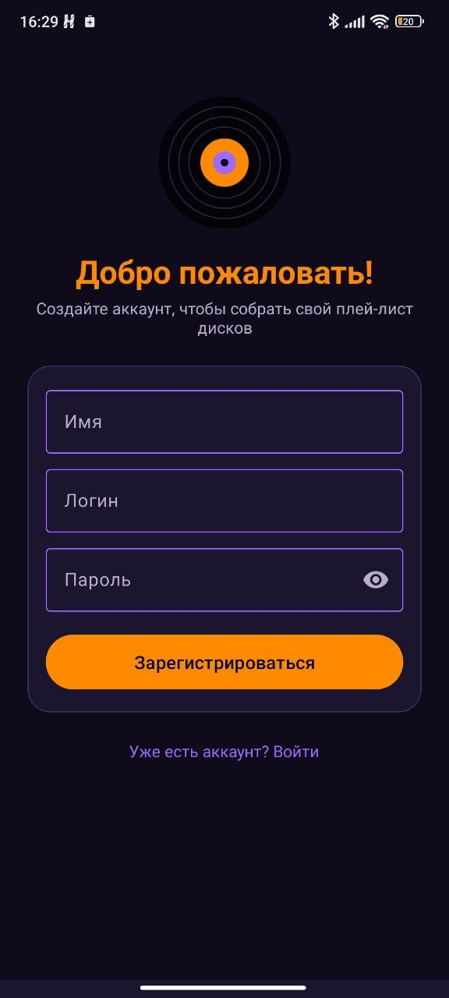 | 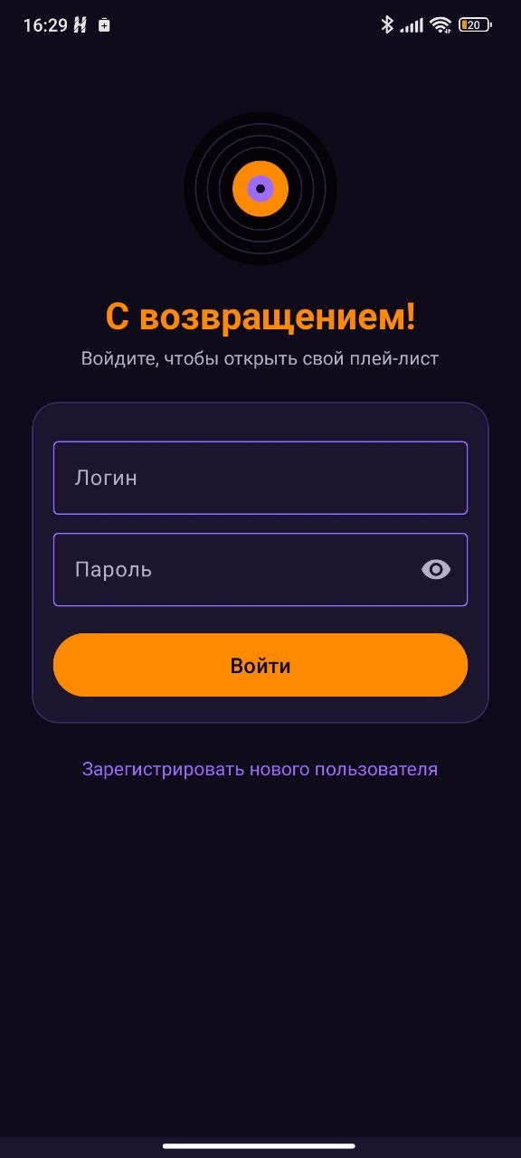 | 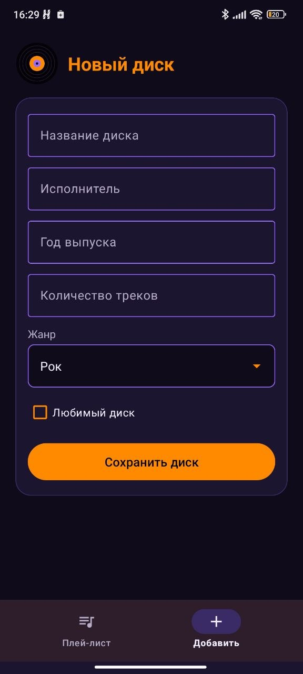 |  | 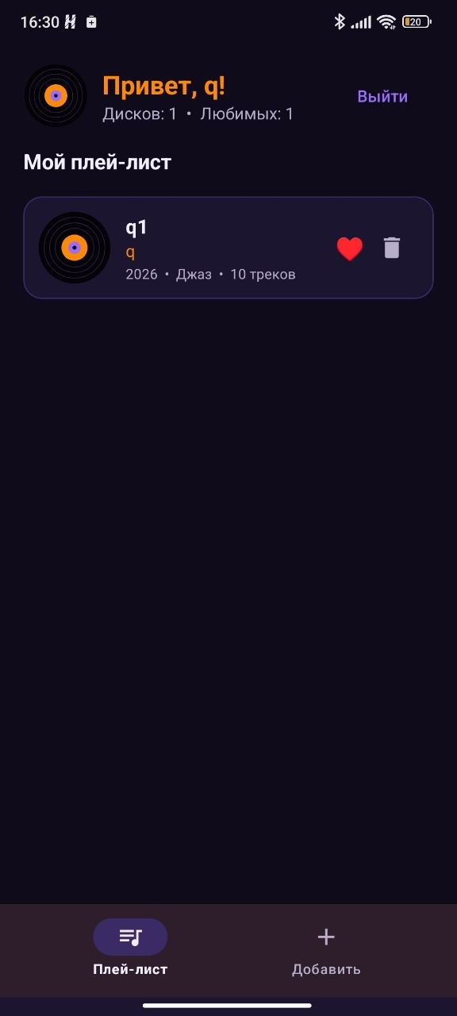
Рисунок 1 – Экран регистрации пользователя | Рисунок 2 – Экран входа (пользователь уже зарегистрирован) | Рисунок 3 – Форма добавления диска |  | Рисунок 4 – Плей-лист сохранённых дисков
Вывод
В ходе практического занятия было разработано приложение «Плей-лист музыкальных дисков» на основе фрагментов. Освоена работа с форматом JSON с помощью библиотеки Gson: объекты User и Disc преобразуются в JSON-строки методом toJson() и обратно методом fromJson(), для списка дисков используется TypeToken. Данные пользователя (регистрация) и список дисков сохраняются в SharedPreferences и остаются доступными после перезапуска приложения.

